Appendix 1.

Hourly weather observations for the years 2006-2015 were collected from Remote Automated Weather Stations (RAWS) at Round Mountain, Tumalo Ridge, and Lava Butte, located in the Deschutes National Forest. Most RAWS units are owned by wildland fire agencies and placed in locations where they can monitor fire danger (http://raws.fam.nwcg.gov, accessed 5 April 2016).

To help understand the diurnal weather patterns around Bend, Oregon, we created wind roses from the RAWS observed winds, following the Northwest Coordination Center (NWCC) format. The wind roses show the frequency of winds blowing from a particular direction, with the length of each spoke around the circle representing the frequency of observations from that direction (http://www.wcc.nrcs.usda.gov/climate/windrose.html, accessed 21 April 2016). Time periods for “daytime” winds include the interval from 1100 – 1800 PST, and nighttime windows include the interval from 0100 – 0700 PST. These time periods capture the general wind patterns during the day and night and attempt to reduce the inclusion of transitions associated with sunrise and sunset. Additionally, the times generally cover daytime and nighttime hours throughout the year and minimize the difference between winter and summer.
We used meteorological seasons to categorize the data, grouping the twelve calendar months into four 3-month periods. Winter includes the months of December, January, and February; spring includes March, April, and May; Summer includes June, July, and August; and autumn includes September, October, and November. This grouping aligns calendar dates more closely with temperatures during that period, as well as allowing easier comparison of weather patterns from one season to another. The wind roses for all RAWS and all seasons are shown below.

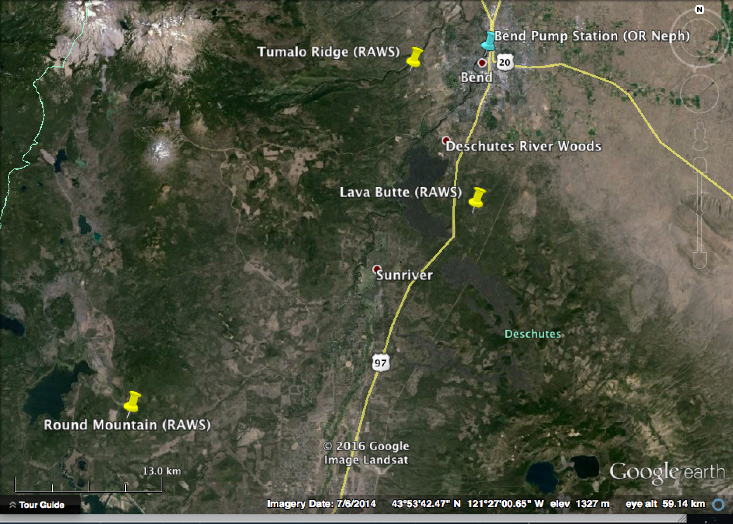

Locations of RAWS stations closest to Bend.

Tumalo Ridge

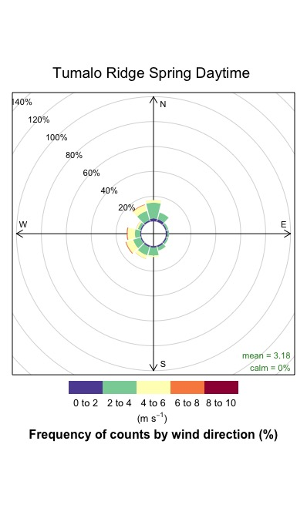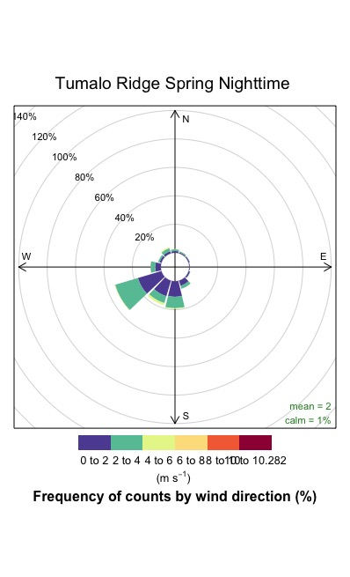

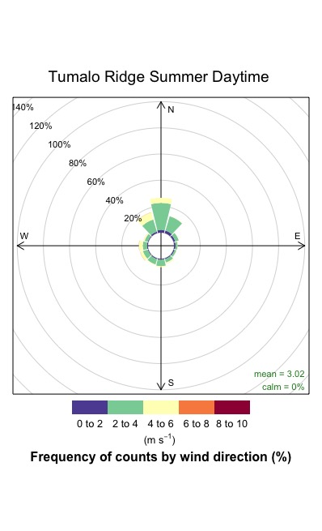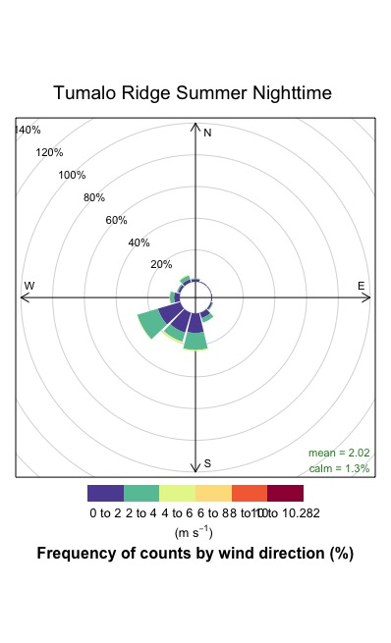

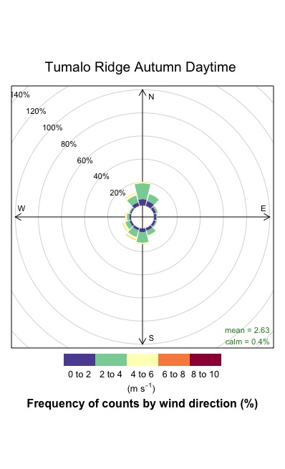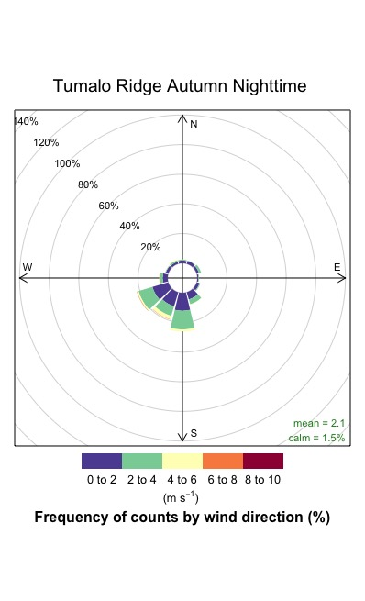
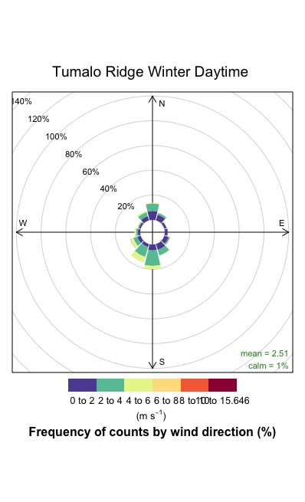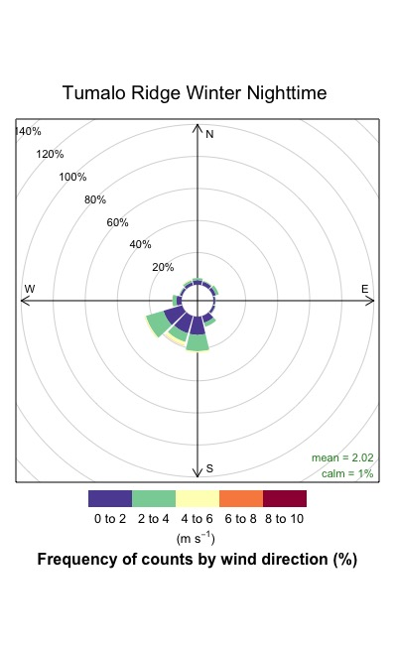

Round Mountain

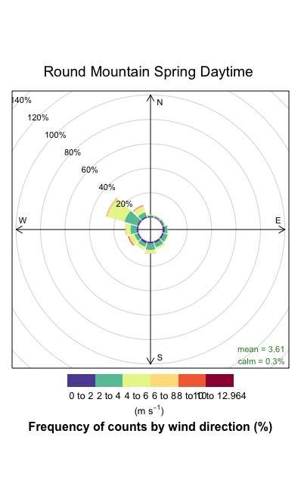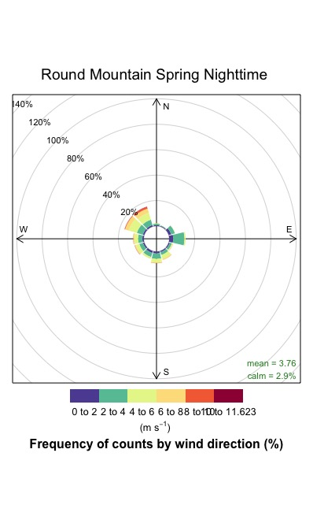
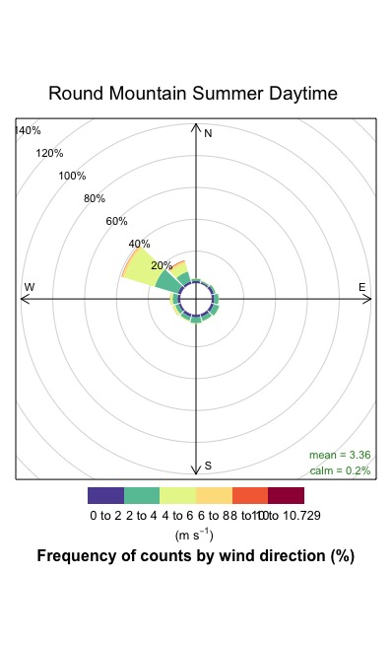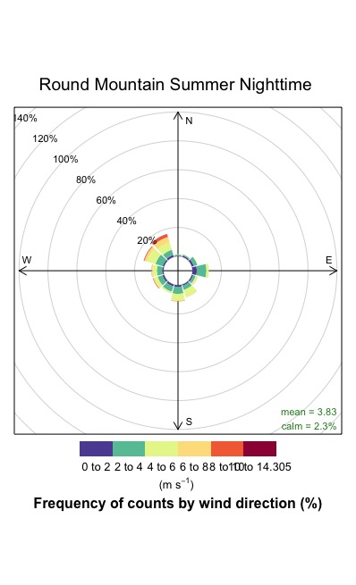

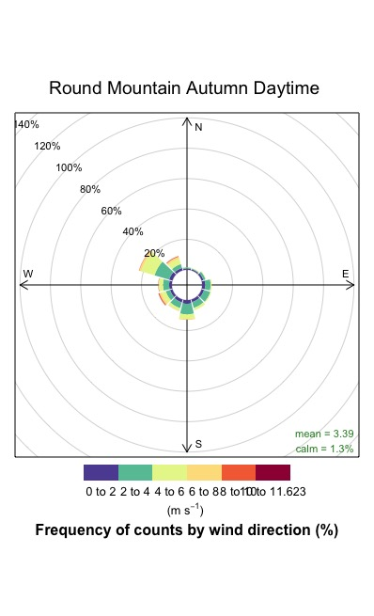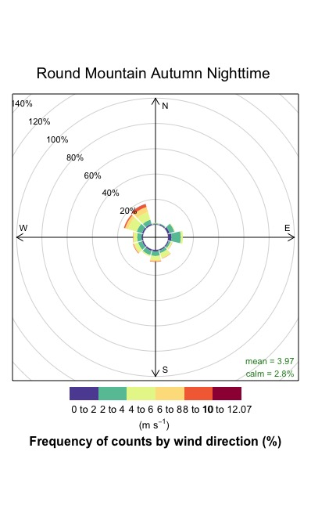

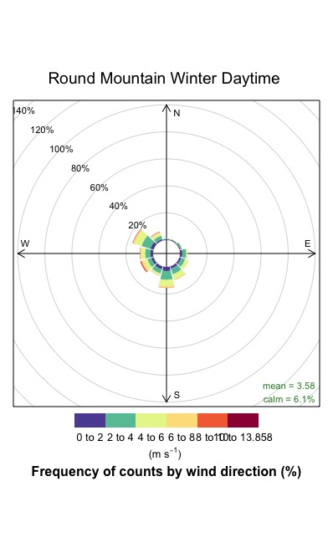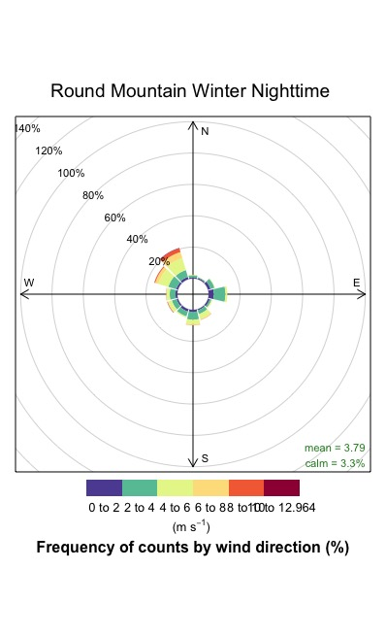

Lave Butte

